

**DEPARTMENT OF ELECTRICAL AND ELECTRONICS ENGINEERING**

PROJECT TITLE

STUDENT NAME, SURNAME AND NUMBER

ADVISOR NAME SURNAME

DATE: XX/XX/XXXX

**EE491 / EE492 PROJECT REPORT**

**ABSTRACT**

**TABLE OF CONTENTS**

**ABBREVIATIONS** 3

**LIST OF FIGURES** 4

**LIST OF TABLES** 5

**1.** **INTRODUCTION** 6

**1.1.** **Sample Subsection** 6

**2.** **PROBLEM DEFINITON** 7

**2.1.** **Sample Subsection for Chapter-2** 7

**2.2.** **Sample Subsection for Chapter-2** 7

**3.** **PROPOSED SOLUTION** 8

**3.1.** **Sample Subsection for Chapter-3** 8

**4.** **RESULTS AND DISCUSSIONS** 9

**5.** **CONCLUSIONS** 10

**REFERENCES** 11

**APPENDIX** 12

# **ABBREVIATIONS**

**IEEE :** Institute of Electrical and Electronics Engineers

**MoM :** Method of Moments

# **LIST OF FIGURES**

**Figure 1** Block Diagram 7

**Figure 2** Radiation Pattern 7

**Figure 3**  Width of the waveguide vs. frequency variation 9

# **LIST OF TABLES**

**Table 1** Dimensions vs Cutoff frequency variation 9

1. **INTRODUCTION**

This section should be devoted to describe related scientific studies (scientific papers, reports, books etc.) which has been published in the literature.

* 1. **Sample Subsection**

The general description of the project and connections of the literature should be mentioned in this section.

This section should briefly mention the **Engineering Standards** and **realistic design constraints** which are considered in the project and will be given in detail **in Section 4**. Note that **sustainability** is especially emhasized in the realistic design constraints. Also consider that Section 4 is a must for this report.

1. **PROBLEM DEFINITON**

The detailed project statement has to be explained in this section.

Equations should be written with an editor e.g. Mathtyp. Formulations cannot be inserted as picture format.

Formulas should be written centered with the equation number, e.g.

$∇×\vec{E}=\frac{−∂\vec{B}}{∂t}$ (1)

Figures and Tables should be also centered and have separate captions, and numbers which are listed in List of Figures and List of Tables, respectively.

Transmitter

Receiver

Channel

**Figure 1** Block Diagram

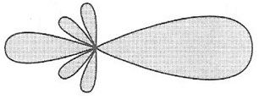

**Figure 2** Radiation Pattern

* 1. **Sample Subsection for Chapter-2**

……………

……………

* 1. **Sample Subsection for Chapter-2**

……………

1. **PROPOSED SOLUTION**

The method which will be used in the project studies should be clarified in this section.

* 1. **Sample Subsection for Chapter-3**

………….

1. **ENGINEERING STANDARDS and DESIGN CONSTRAINTS**

Provide detailed information about which standard was used in the project.

An example list of engineering standards is given below:

* LOS ALAMOS National Labs Standards <http://engstandards.lanl.gov/ESM_Chapters.shtml>
* ANSI American National Standards Institute <http://webstore.ansi.org/>
* IEEE standards <http://standards.ieee.org/>
* ETSI 3gpp standards <http://etsi.org/>
* IEEE standards university <http://www.standardsuniversity.org/>
* ISO searchable standards database <http://www.iso.org/iso/home/standards.htm>
* UL safety <http://www.ul.com/>
* ASTM Standards <https://www.astm.org/Standard/>
* NIST Standards <https://www.nist.gov/>
* TSE Turkish Standards Institute [www.tse.org.tr/](http://www.tse.org.tr/)

Provide detailed information about which design constraints were used in the project.

The list of some realistic design constraints:

**Economy:**

* Budget limitations
* Cost of similar or related products, if any, on the market.
* Maintenance cost

**Environment:**

* Power consumption
* Electromagnetic radiation issues
* Environment friendly power sources
* Noise pollution

**Society:**

* Assisted living for the disabled and elderly
* Information security, privacy
* Social networking and communication

**Politics:**

* Designs that promote gender and race equality
* Products that help national security
* Designs that help solve common international and national problems

**Ethics:**

* Designs that do not violate safety and health issues.
* Designs that respect patents and intellectual rights.
* Privacy issues.
* Honesty, truthfulness, and openness in the design and the report.

**Health and Safety:**

* Public safety
* Safety of the consumers of the product.
* Safety of workers.

**Manufacturability:**

* Designs that suit to current manufacturing technology.
* Designs that can be physically implemented.

**Sustainability:**

* Reliability and durability of the design (water-proof, dust-proof, etc.)
* Designs that support future upgrades
* Designs that are resilient to a range of environmental conditions.

1. **RESULTS AND DISCUSSIONS**

Results obtained during the project study should be presented in this section. Discussions on the scientific findings should be reported in a clear form.

|  |  |  |  |
| --- | --- | --- | --- |
| **Waveguide Type** | **width (cm)** | **height(cm)** | **Cuttoff frequency of TE11 (GHz)** |
| WG-1 | 1 | 1 | 21.213 |
| WG-2 | 2 | 1 | 16.770 |
| WG-3 | 3 | 1 | 15.811 |
| WG-4 | 4 | 1 | 15.461 |

**Table 1** Dimensions vs Cutoff frequency variation

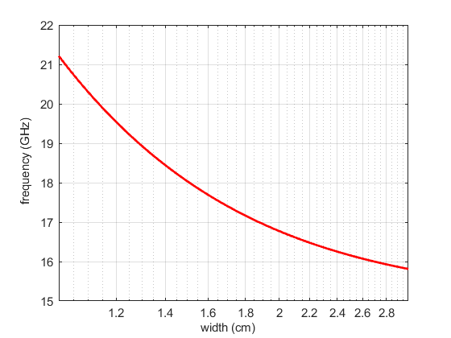

**Figure 3**  Width of the waveguide vs. frequency variation

1. **CONCLUSIONS**

General description of the project, the most interesting contributions and observations, and possible extensions should be emphasized in here.

# **REFERENCES**

**[1]** Einstein, A., Podolsky, B., & Rosen, N. (1935). Can quantum-mechanical description of physical reality be considered complete?. *Physical review*, *47*(10), 777.

**[2]** Cover, T. M., & Thomas, J. A. (2012). *Elements of information theory*. John Wiley & Sons.

**[3]** Grossglauser, M., & Tse, D. (2001). Mobility increases the capacity of ad-hoc wireless networks. In INFOCOM 2001. *Twentieth Annual Joint Conference of the IEEE Computer and Communications Societies*. Proceedings. (Vol. 3, pp. 1360-1369).

# **APPENDIX**